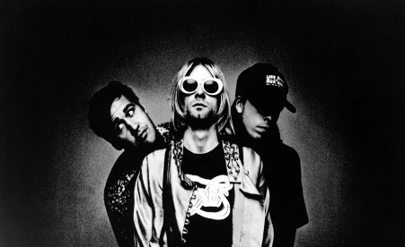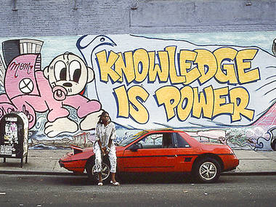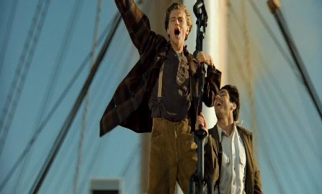
Come As You Are: Pop, Grunge, and CGI
Music, Art, technology and Fashion of the 1990s
The 90s were a decade that continued to see a lot of change in music. Music genres such as grunge- Pearl Jam, Nirvana, and Stone Temple Pilots-, hip hop- Tupac and the Notorious BIG-, and pop bands- The Backstreet Boys, the Spice Girls- were all immensely popular. Digital art developments such as Computer Generated Imagery made it possible for movies like Toy Story to be made.
Possible optional assignments:
- Sketch your own album design that reflects the era. Try this with either pencil, crayon, pastel, watercolor, acrylic, etc. if you have the supplies. If you do not just sketch with a pencil for fun and relaxation.
- In Office 365 produce a Power point or Microsoft Word presentation on the musician of your choice from the 90’s (Nirvana, Pearl Jam, Tupac, NSYNC, Mariah Carey, etc). Research where they grew up, their education, most popular songs, hobbies, where they are now, etc. Talk to your parents, grandparents, guardians, etc. about your findings…use the phone and call them (social distancing).
- In Office 365 produce a Power point or Microsoft Word presentation on artist of your choice from the 90’s(Andreas Gursky, Elizabeth Peyton), Research where they grew up, their education, most popular works, hobbies, where they are now, etc. Talk to your parents, grandparents, guardians, etc. about your findings…use the phone and call them (social distancing)
Note: If you are doing a Power Point or Word Presentation play around with the animations and transitions to keep yourself sharp. Try inserting a video or music. Use YouTube for help with any of these options or email me. LeRoy.Vincent@nbed.nb.ca
In your class files for week 4 look at the sketch book prompts file I’ve placed for you to practice…. if you have the time.

